4. SQL Exercise - Stored procedure
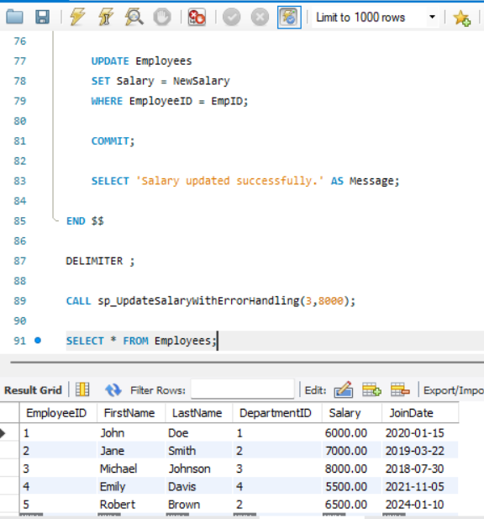

-- Create Database
CREATE DATABASE IF NOT EXISTS EmployeeDB;
USE EmployeeDB;

-- Drop Tables
DROP TABLE IF EXISTS Employees;
DROP TABLE IF EXISTS Departments;

-- Create Tables

CREATE TABLE Departments (
DepartmentID INT PRIMARY KEY,
DepartmentName VARCHAR(100)
);

CREATE TABLE Employees (
EmployeeID INT AUTO_INCREMENT PRIMARY KEY,
FirstName VARCHAR(50),
LastName VARCHAR(50),
DepartmentID INT,
Salary DECIMAL(10,2),
JoinDate DATE,
FOREIGN KEY (DepartmentID) REFERENCES Departments(DepartmentID)
);

-- Insert Sample Data

INSERT INTO Departments VALUES
(1,'HR'),
(2,'Finance'),
(3,'IT'),
(4,'Marketing');

INSERT INTO Employees
(FirstName,LastName,DepartmentID,Salary,JoinDate)
VALUES
('John','Doe',1,5000.00,'2020-01-15'),
('Jane','Smith',2,6000.00,'2019-03-22'),
('Michael','Johnson',3,7000.00,'2018-07-30'),
('Emily','Davis',4,5500.00,'2021-11-05');

--------------------------------------------------
-- Exercise 1
-- Create Stored Procedure
--------------------------------------------------

DELIMITER $$

CREATE PROCEDURE sp_GetEmployeesByDepartment(
IN DeptID INT
)
BEGIN
SELECT *
FROM Employees
WHERE DepartmentID=DeptID;
END $$

DELIMITER ;

CALL sp_GetEmployeesByDepartment(1);

--------------------------------------------------
-- Insert Employee Procedure
--------------------------------------------------

DELIMITER $$

CREATE PROCEDURE sp_InsertEmployee(
IN pFirstName VARCHAR(50),
IN pLastName VARCHAR(50),
IN pDepartmentID INT,
IN pSalary DECIMAL(10,2),
IN pJoinDate DATE
)
BEGIN
INSERT INTO Employees
(FirstName,LastName,DepartmentID,Salary,JoinDate)
VALUES
(pFirstName,pLastName,pDepartmentID,pSalary,pJoinDate);
END $$

DELIMITER ;

CALL sp_InsertEmployee(
'Robert',
'Brown',
2,
6500,
'2024-01-10'
);

SELECT * FROM Employees;

--------------------------------------------------
-- Exercise 2
-- Modify Stored Procedure
--------------------------------------------------

DROP PROCEDURE IF EXISTS sp_GetEmployeesByDepartment;

DELIMITER $$

CREATE PROCEDURE sp_GetEmployeesByDepartment(
IN DeptID INT
)
BEGIN
SELECT EmployeeID,
FirstName,
LastName,
Salary,
DepartmentID
FROM Employees
WHERE DepartmentID=DeptID;
END $$

DELIMITER ;

CALL sp_GetEmployeesByDepartment(2);

--------------------------------------------------
-- Exercise 3
-- Delete Stored Procedure
--------------------------------------------------

DROP PROCEDURE sp_InsertEmployee;

--------------------------------------------------
-- Exercise 4
-- Execute Stored Procedure
--------------------------------------------------

CALL sp_GetEmployeesByDepartment(3);

--------------------------------------------------
-- Exercise 5
-- Return Total Employees in a Department
--------------------------------------------------

DELIMITER $$

CREATE PROCEDURE sp_TotalEmployees(
IN DeptID INT
)
BEGIN
SELECT COUNT(*) AS TotalEmployees
FROM Employees
WHERE DepartmentID = DeptID;
END $$

DELIMITER ;

CALL sp_TotalEmployees(1);

--------------------------------------------------
-- Exercise 6
-- Output Parameter
--------------------------------------------------

DELIMITER $$

CREATE PROCEDURE sp_TotalSalary(
IN DeptID INT,
OUT TotalSalary DECIMAL(10,2)
)
BEGIN
SELECT SUM(Salary)
INTO TotalSalary
FROM Employees
WHERE DepartmentID = DeptID;
END $$

DELIMITER ;

CALL sp_TotalSalary(1,@TotalSalary);

SELECT @TotalSalary;

--------------------------------------------------
-- Exercise 7
-- Update Employee Salary
--------------------------------------------------

DELIMITER $$

CREATE PROCEDURE sp_UpdateEmployeeSalary(
IN EmpID INT,
IN NewSalary DECIMAL(10,2)
)
BEGIN
UPDATE Employees
SET Salary = NewSalary
WHERE EmployeeID = EmpID;
END $$

DELIMITER ;

CALL sp_UpdateEmployeeSalary(1,5500);

SELECT * FROM Employees;

--------------------------------------------------
-- Exercise 8
-- Give Bonus
--------------------------------------------------

DELIMITER $$

CREATE PROCEDURE sp_GiveBonus(
IN DeptID INT,
IN Bonus DECIMAL(10,2)
)
BEGIN
UPDATE Employees
SET Salary = Salary + Bonus
WHERE DepartmentID = DeptID;
END $$

DELIMITER ;

CALL sp_GiveBonus(1,500);

SELECT * FROM Employees;

--------------------------------------------------
-- Exercise 9
-- Transaction in a Stored Procedure
--------------------------------------------------

DELIMITER $$

CREATE PROCEDURE sp_UpdateSalaryTransaction(
IN EmpID INT,
IN NewSalary DECIMAL(10,2)
)
BEGIN
START TRANSACTION;

UPDATE Employees
SET Salary = NewSalary
WHERE EmployeeID = EmpID;

COMMIT;
END $$

DELIMITER ;

CALL sp_UpdateSalaryTransaction(2,7000);

SELECT * FROM Employees;

--------------------------------------------------
-- Exercise 10
-- Dynamic SQL in a Stored Procedure
--------------------------------------------------

DELIMITER $$

CREATE PROCEDURE sp_DynamicSearch(
IN ColumnName VARCHAR(50),
IN SearchValue VARCHAR(100)
)
BEGIN
SET @sql = CONCAT(
'SELECT * FROM Employees WHERE ',
ColumnName,
' = ?'
);

PREPARE stmt FROM @sql;
SET @value = SearchValue;
EXECUTE stmt USING @value;
DEALLOCATE PREPARE stmt;
END $$

DELIMITER ;

CALL sp_DynamicSearch('FirstName','John');

--------------------------------------------------
-- Exercise 11
-- Error Handling in a Stored Procedure
--------------------------------------------------

DELIMITER $$

CREATE PROCEDURE sp_UpdateSalaryWithErrorHandling(
IN EmpID INT,
IN NewSalary DECIMAL(10,2)
)
BEGIN

DECLARE EXIT HANDLER FOR SQLEXCEPTION
BEGIN
ROLLBACK;
SELECT 'An error occurred while updating salary.' AS Message;
END;

START TRANSACTION;

UPDATE Employees
SET Salary = NewSalary
WHERE EmployeeID = EmpID;

COMMIT;

SELECT 'Salary updated successfully.' AS Message;

END $$

DELIMITER ;

CALL sp_UpdateSalaryWithErrorHandling(3,8000);

SELECT * FROM Employees;

